**SMART SHOP**



|  |  |
| --- | --- |
| **S.No** | **Project Team Members:** |
| **1** | Shashi Vardhan Reddy (Team Leader) |
| **2** | Reshmitha |
| **3** | Nikhil Sai |
| **4** | UdaySai |
| **5** | Vishnuvardhan |

1.0 Document Purpose

This Project deals with Online Shopping Management System (SMARTSHOP) which helps the consumers to directly buy goods over the Internet , details of the previous orders and returns, details of sellers and a lot more. All These are recorded in One secure place which can be accessed only by the Admin.

This project includes modules such as

1. Admin module
2. Consumer Profile module
3. Seller Profile module
4. Profit module
5. Daily Sales Analysis Report

# 2.0 Module Use case

**2.1 Consumer module**

This module contains User Registration and User Login page which retrieves and Stores the Consumer record. The Consumer can come to know the items available for shopping and their previous orders details through this module.

This module contains sub-modules which are mentioned below:

* User id
* User Name
* User Password
* City
* Address
* Ordered items

**2.2 Seller Profile module**

This module manages and updates the information about Seller such as Personal details, contact information, Unit assignment history, equipment and weapons management etc. This module also records all disciplinary actions, Lawsuits, awards and advancements.

* Seller Id
* Seller Name
* Seller Password
* Seller type
* Seller address
* Seller Gender
* Seller Age

# 3.0 Design and Implementation Constraints

**3.1 Database:** The system shall use Oracle Database, which is open source and free.

**3.2 Operating System:** The Development environment shall be Windows10.

**3.3 Web-Based:** The system shall be a Web-based application.

**4.0 Define module & Functionality:**

The system functions can be described as follows:

**Registration:** The Seller and consumer needs to be registered in this Application before using it. So, every Seller and consumer should register in it . For registering , the Seller and Consumer enters all his personal details including . After registration , The Seller can login and Sell their poducts and Consumer can buy from the Application.

**Login:** When Id and password is matched it allows the Seller or Consumer to dashboard or else it denies the Seller and Consumer to Enter into Application.

**5.0 System Analysis**

System analysis is the first and foremost step performed in developing the software to solve a particular problem. In the analysis part, a software developer examines the requirements. Carrying out preliminary investigation identifies these requirements

Analysis consists of two sub phases

1. Planning
2. Requirement definition

During planning phase, cost estimates and work schedules will be planned. Requirement definition is a specification that describes the processing environment, the required software functions, performance constraints (size, speed, machine configuration) and exception handling.

**6.0 Technical:**

1. **SQL**
2. **JAVA (1.8)**

**Front End: HTML, CSS, JAVASCRIPT.**

**Back End: JAVA, ORACLE SQL DB, JSP Servlets.**

**……………………………………………………………………………………………………….**

**Sign Up page**

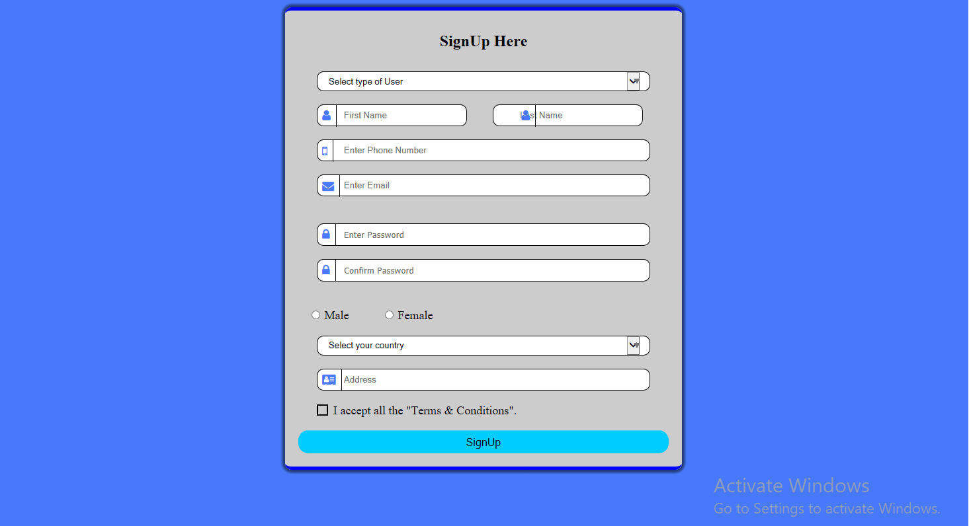

**Login page**

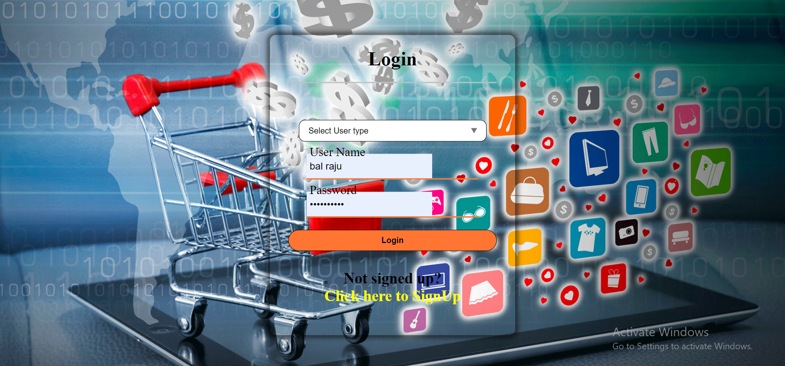

**Home page**

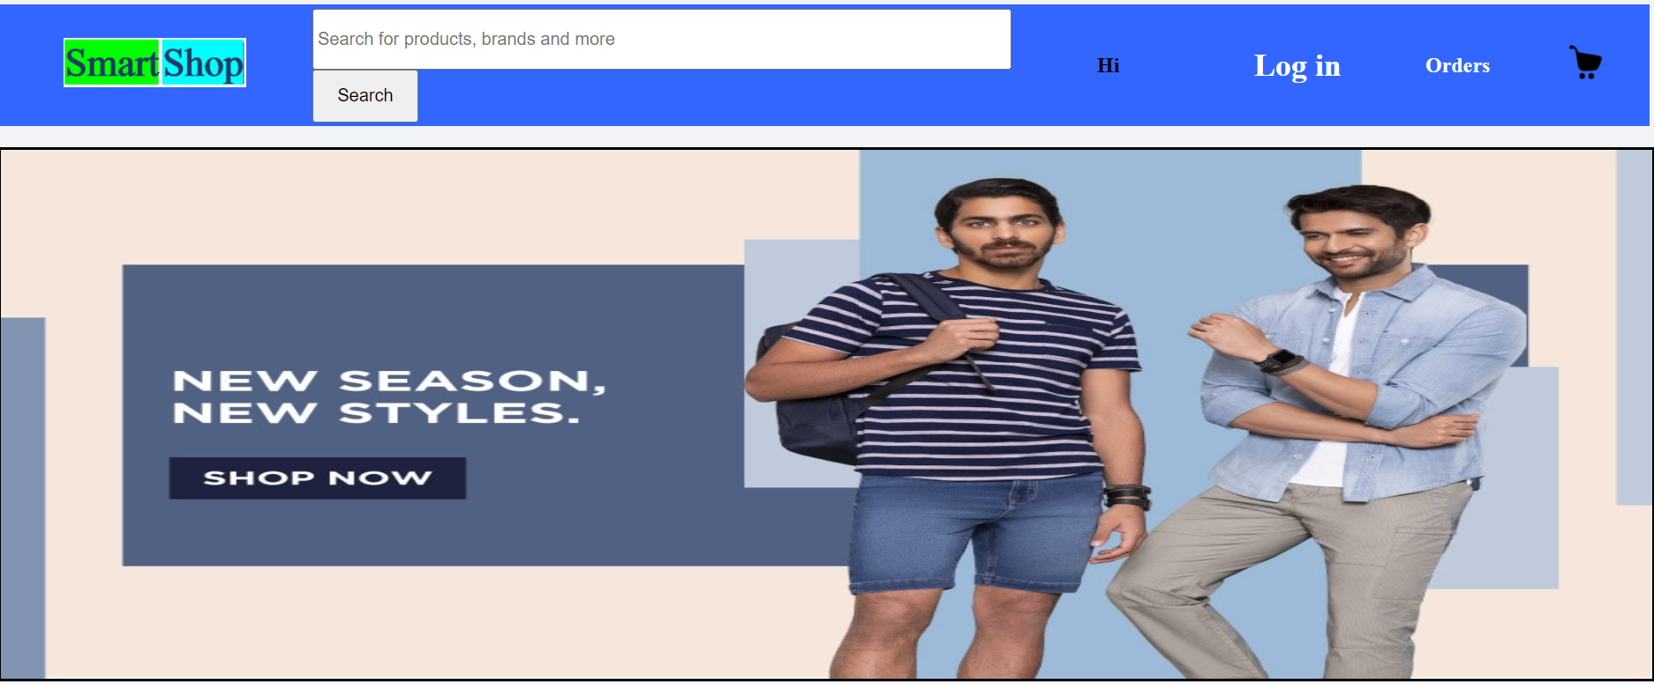

**Add products by seller:**

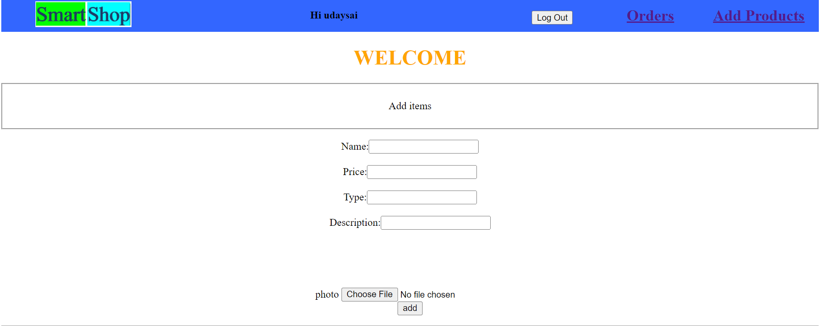

**Cart page of a Consumer**

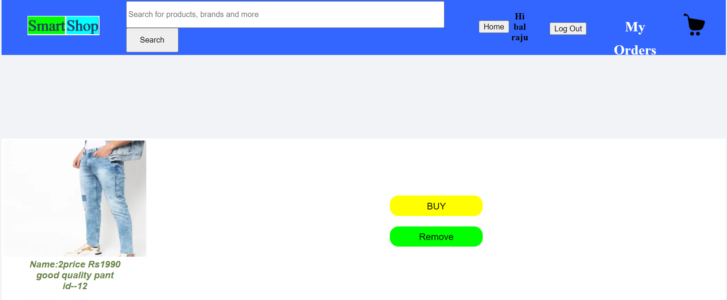

**Seller Home page**

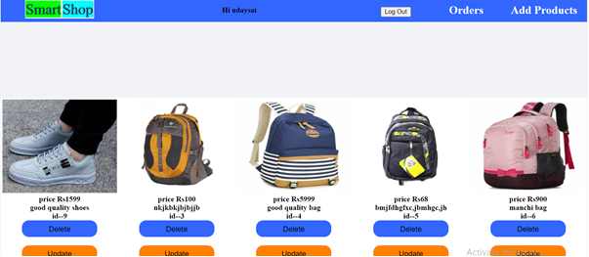

**Orders Page (Consumers)**

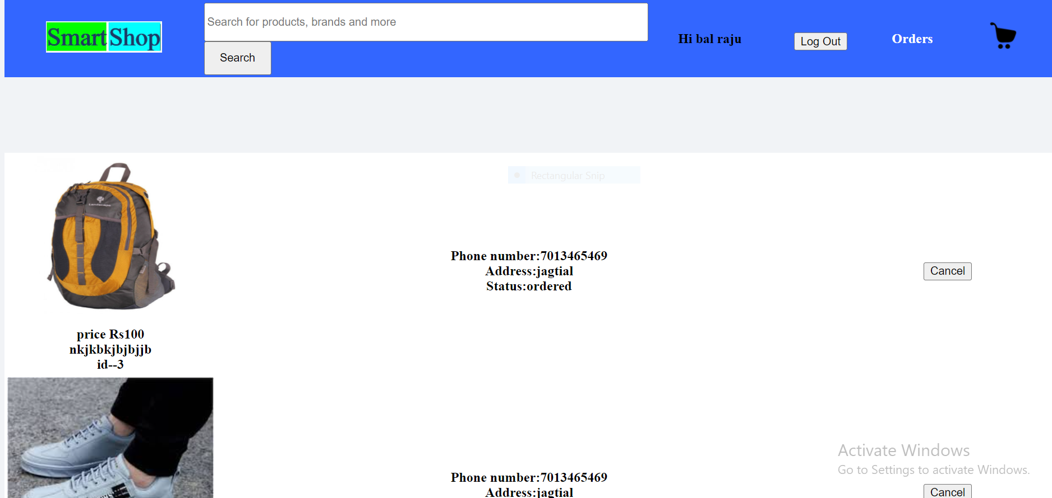

**Sellers order delivery status approval page**

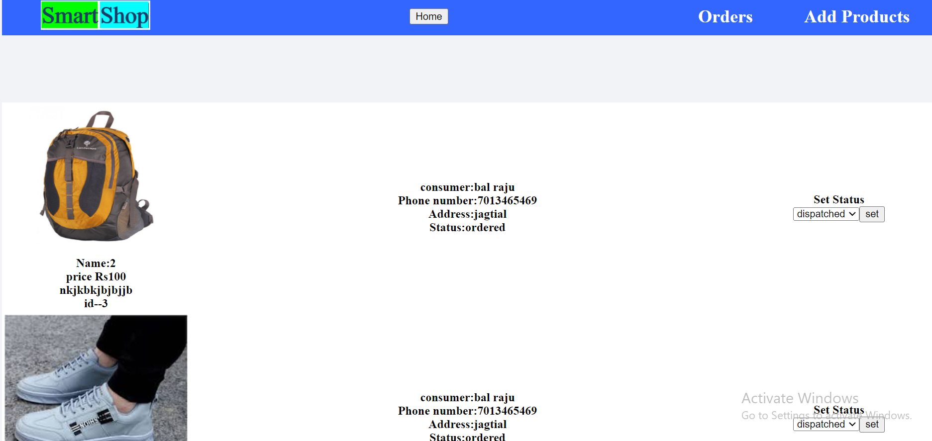

**Conclusion:**

The first technology investment every retailer should consider is the Smart shop.   
Just as the world has developed affinity for the smart home a smart store is the business version. We have learned

The Shopping System will be computerized and most of the Shopping is done through online. Shopping of different things will be easy and fast. Easy to manage Shopping, we can send gifts through this Smart Shop. Order details and Seller Details is stored in the Database.